**Planning 1**

Before starting a project like this, it is important to have an idea of the timescales of each sub-task and to set yourself deadlines. This should be done before beginning any other aspect of the product. As well as tasks that need to be completed, I have included key periods, such as the examination period, during which my time to work on my EP will be severely limited. It is difficult to apply such a rigid structure to my project as I plan on approaching it with the *Agile* method (see development section) and this type of scope-bound sectioning is at odds to that methodology but it is still useful to draft an overarching plan. I feel that a Gantt chart is best suited to displaying this information.

Though I am aiming for the October hand-in date, in my mind the project must be essentially complete by the EP marketplace on 08/09/2016.

1. **Planning and Design**

As part of this phase, I will draw up basic diagrams using CAD tools in order to further my IT skills and so I have an idea of what the final product will actually look like.

1. **HTML & CSS Basics**

HTML and CSS are what hybrid apps are built from, and will be essential for my project. I have chosen to call this “basics” because improvement of programming skills are an ongoing process for any developer.

1. **JavaScript Basics**

JavaScript is a very popular programming language used heavily in web development. Its role is to make things happen on the website, such as creating interactive dialogue boxes or displaying a slideshow of images

1. **Git Basics**

Git is a version control software, essential for any development project, enabling features such as revision, merging and reverting (see development section for more on git).

1. **UI**

UI stands for User Interface. It is essentially the interface that the user will see on the screen. I have given this a very long time period on my chart because it is a feature which is continuously adapted.

1. **Frame**

A frame for my mirror needs to be constructed out of wood.

1. **Mirror**

I will need to buy a one-way mirror that is either already cut to size or cut it myself.

1. **Time Widget**

This is the most basic function of my mirror.

1. **Weather Widget**

This is a core feature of my mirror. To be a useful device the mirror must display helpful information. At this point the app is what is known as the Minimum Viable Product (MVP).

1. **Additional Features**

I have grouped these together as one item (as opposed to my core features, time and weather) because these are stretch-goals rather than primary targets. I will implement as many of these as possible with the remaining time I have, but not until my core features are complete. This is in accordance with my Agile development methodology. These additional features may include:

* Voice control
* RSS news feed
* Calendar/Agenda
* Compliment
* Face API
* Traffic information

Since this is the first time I have ever attempted anything like this before, it difficult to put an estimated completion time on these features, so I have just allocated as much time as possible.

1. **Examination period**

From the end of Easter to the end of the exam period I will be putting my project on a hiatus in order to concentrate on revision.

1. **Holidays**

These are periods where I hope to make more progress than a normal working week. This is with the exception of the half-term during the examination period during which I will be studying.

Codecademy courses are structured into units and lessons. For example the HTML & CSS course is as follows:

UNIT 1: INTRODUCTION TO HTML

* HTML Basics
* Build Your Own Webpage

UNIT 2: HTML STRUCTURE: USING LISTS

* HTML Basics II
* Social Networking Profile

UNIT 3: HTML STRUCTURE: TABLES, DIVS AND SPANS

* HTML Basics III
* Clickable Photo Page

Etc.

During the normal school period I estimate that I will be able to complete 2 units of the HTML or JavaScript course every week. There are 6 units in the HTML & CSS course and 8 units in the JavaScript course. Therefore I shall assign 7 weeks to completing both the web and JavaScript courses. The git course is much shorter than the other courses should take just one dedicated week to complete as it is much shorter than any other so I’ll spread the git course over 2 weeks in parallel to the other two courses. This is illustrated in my Gantt diagram.

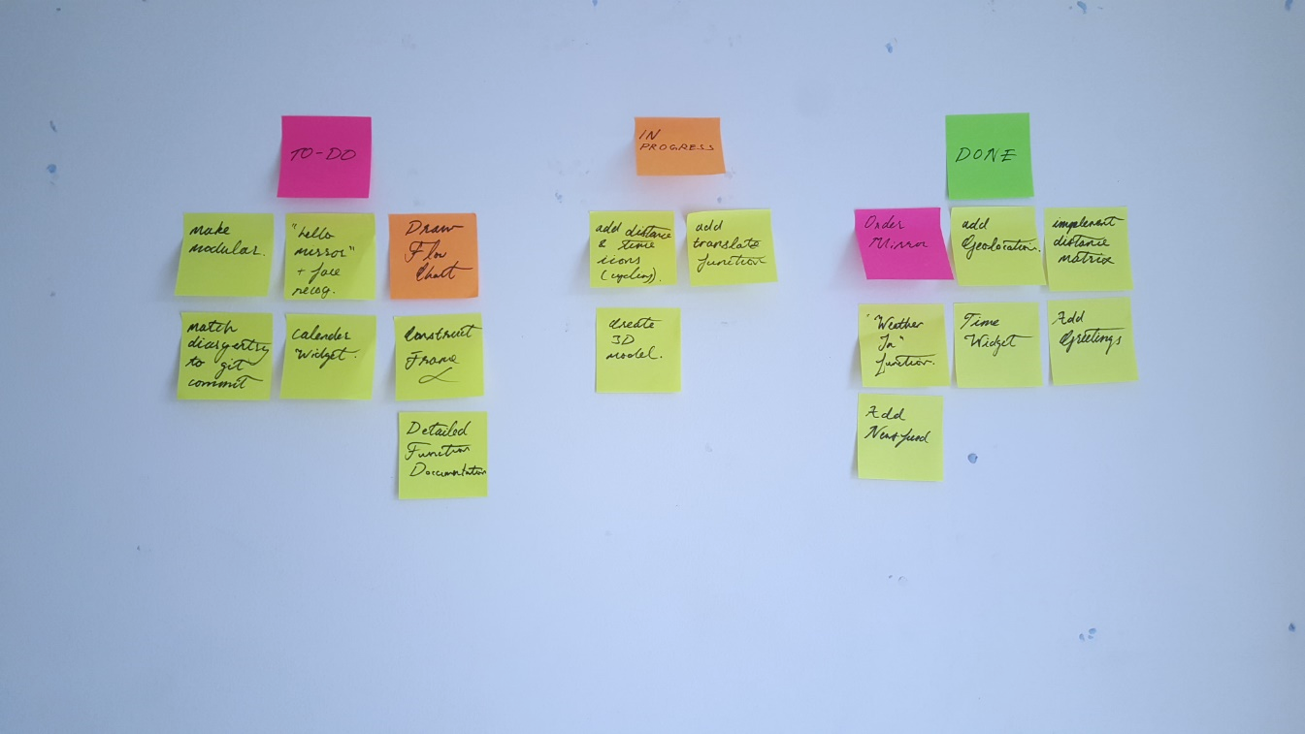I am also using a system of sticky notes on my wall which gives me a convenient way to keep track of features to be completed. Here is the state of the wall sometime midway through the project.

Fig 3.1 – Using sticky notes to track progress